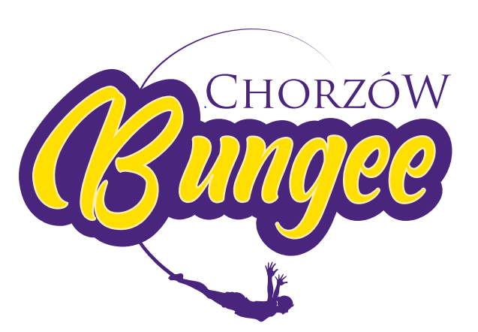STATEMENT (16+)

…………………………………………………………………*
Name, surname, date of birth
(Should be filled in legibly with capital letters)

…………………………………………………………………*
Address
(Should be filled in legibly with capital letters)

I hereby declare, that all the facts and information provided below are true:
1. I am over 18 years old;
2. As a parent / legal guardian of minor person…………………………(name & surname)* I give permission to perform a bungee jump;
3. I am aware of the fact bungee jumping is an extreme sport that involves risks and unforeseen situations (e.g. contact with elastic bungee cord etc.) for which the organizer does not take responsibility, because they can occur regardless of the organizer's activities or his due diligence and safety rules; . I voluntarily subscribe to it and I will not claim grievances and compensation from organizer Bungee Jumping Chorzów.
4. I read and comply to Rules & Regulations of Bungee Jumping Chorzów, I accept it and I have no objections or comments to the Rules & Regulations and I am aware of the consequences of not respecting it, or concealing the circumstances of admissibility or the possibility of bungee jumping including health;
5. I declare that minor person is not under influence of alcohol or any kind of drugs or intoxicants;
6. Minor person’s health (medical state) is good and there are no medical contraindications to perform a jump on a bungee cord, in particular below mentioned diseases, diseases or health defects like following:
- vision defects and eye diseases ,visual impairment ( 3 diopter and more) and/or eye diseases ( such as retinal disease, glaucoma, condition after surgery)
- asthma, epilepsy, psychosis, depression, paresis, post-stroke status, panic/anxiety attacks, neurological disorders;
- pregnancy
- broken or fractured bones, fractures of the lower limbs, fractures and pelvic injuries, spine diseases (discopathy, fractures, spondylolisthesis, osteoporosis, congenital and acquired defects, significant spinal curvature)
- high blood pressure, uncontrolled hypertension, cerebrovascular disease, aortic aneurysm, condition after arterial vessels surgery, large varices of lower limbs, lower limb ischemia, ischemic heart disease, heart failure, arrhythmias, etc.
- chronic ear ailments with disturbance of equilibrium
7. Minor person has no prostheses or implants or ornaments or body modifications (e.g. chokers, tunnels, etc.) that could bend, break, tear or dislodge during a jump on a bungee cord or cause any bodily injury, including internal organs;
8. Due to the awareness of the risk associated with bungee jumping I voluntarily and fully deliberately renounce all claims, including compensatory ones, against the organizer of Bungee Jumping Chorzów jumps, which could result from the occurrence of circumstances for which the organizer is not responsible or not compliance with the rules of jumping on a rubber bungee line or with concealment of circumstances relevant to admissibility or the possibility of jumping on a bungee cord.

…………………………………………
Place, date and legible signature

I hereby declare - in connection with the purchase of photos or video from the GoPro webcam- I agree to:
1. the processing of minor person’s personal data and the use of the image for the purposes of:
- performing the contract,
- for marketing purposes (posting on Facebook, website)
on the terms compliant with generally applicable laws …………………………………………
Place, date and legible signature

