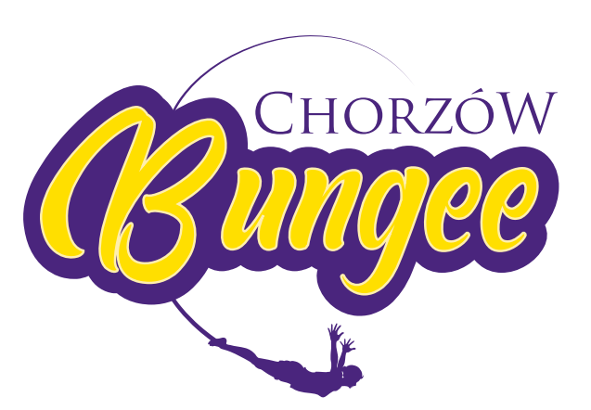

Bungee Jumping Chorzów Regulation

- To take part in bungee jumping activity, every participant must get familiar with the regulations, accept it and comply to it what’s confirmed with your signature.

- Participation in bungee jumping activity in Bungee Jumping Chorzów under the influence of drugs, alcohol or antipsychotic drugs or similar is prohibited.

- It is forbidden to undertake a bungee jump by people, who are suffering from troubles such as:

- circulatory system,
- heart diseases,
- epilepsy,
- people after strong injuries of lower extremity, pelvis, backbone problems
or after backbone injuries or any part of body, that should not be exposed to extreme activity,
- varicose veins of the lower limbs, paresis, osteoporosis, discopathy.
- recent concussion
- broken or fractured bones/dislocations
- asthma
- panic/anxiety attacks
- any recent sprains/muscular injuries
- high blood pressure
- neurological disorders
- damage to the musculoskeletal system
- recent eye-surgery
- chronic ear ailments with disturbance of equilibrium
- shouldering shoulders, multiple sprains of the ankles or recurring injuries also constitute a contraindication to a jump on a rubber bungee line.

- Participation in bungee jumping activity in Bungee Jumping Chorzów for pregnant women and people with silicone implants of any kind and prosthetics is prohibited.

- Due to the overload during the jump (2G), contraindication for jump are severe visual impairment (3 diopter and more), eye diseases such as retinal disease, glaucoma, condition after surgery).
- It is obligatory to leave all your stuff from the pocket, that may fall out during the jump, especially cell phone, wallet, keys, lighter. Take off all the jewelry.

- It is forbidden to catch a bungee cord during the jump.

- Participants are obligated to inform the organizer of any health hazards.

- Minors need their parent's or supervisor's consent.

- Bungee Jumping Chorzów does not take responsibility for any damage caused inconsequence of noncompliance to the regulations, concealing important facts or declaring the untruth.

- If you are between 16 and 18 years old, you need to have your legal parents’ agreement and the jump is performed during his/her presence.

- Jumpers over 60 years old must present a medical certificate of no medical contraindications to bungee jump.

- If you won’t uphold to the rules, the Organizer may refuse you to undertake a bungee jump without giving a reason. In case the jump has already been performed, Bungee Jumping Chorzów does not take responsibility for any of the damage you obtained.

- Bungee Jumping Chorzów reserves the right to refuse anyone to perform a jump, without an explanation.

- If the jumper after the second signal from instructor (3, 2, 1 bungee) will not jump, cannot claim compensation.

- If you would like to receive an invoice, please let instructor know before payment.

If you have any doubts about the state of his health, consult the appropriate specialist before jumping, especially if you suffer from diabetes.

Remember! Extreme sports such as bungee jumping carries a risk and doing it with disregard of regulations and instructions can be dangerous.

